Meet Our New Pilates Instructor - Jennifer Clydesdale.

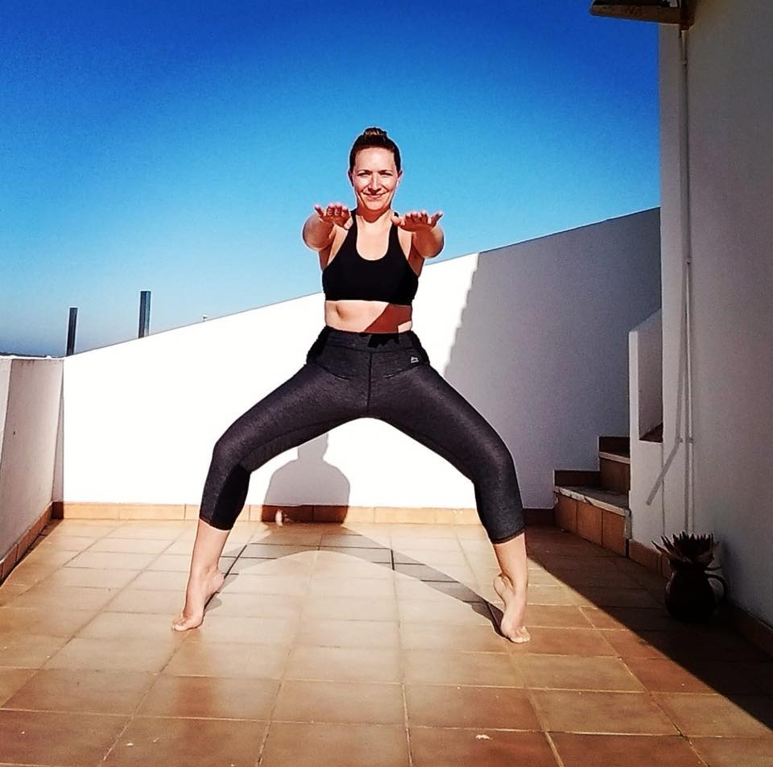

Jennifer is a fully qualified, HCPC (Health Care Professionals Council) and CSP (Chartered Society of Physiotherapists) registered Physiotherapist. Jennifer boasts over 13 years experience as a Physiotherapist working in a variety of areas and clinical settings. Her main specialty and interest is in Women’s Health and Pilates.
Jennifer is trained in the APPI Pilates method.
Why choose APPI Pilates?
The APPI Pilates method was developed by Elisa and Glenn Withers who are both Physiotherapists. They analysed the traditional Pilates movements and then developed graded movements based on each exercise that can be adapted to better suit each individual taking part. The overall aim of the APPI Pilates method is to develop the Deep Postural Core muscles that support the spine throughout postural movements, enhance normal movement patterns and improve overall body alignment.
Class Details:-
Tuesday Evenings starting 17th July onwards - 8.15pm-9.15pm Ayrshire Athletics Arena (Mats and equipment provided)
Block Bookings £42 for 6 classes OR PAYG £8 per class
**discounts apply for Kilmarnock Harriers**
Contact the Move Better Team to Book Your Place Now on:- 0844 802 7043 or info@movebetterphysio.com

